Atelier 2

Eva Pimont

15/10/2019

## R Markdown

This is an R Markdown document. Markdown is a simple formatting syntax for authoring HTML, PDF, and MS Word documents. For more details on using R Markdown see <http://rmarkdown.rstudio.com>.

When you click the **Knit** button a document will be generated that includes both content as well as the output of any embedded R code chunks within the document. You can embed an R code chunk like this:

Les principaux types de vecteurs

Dans R, il existe quatre types fondamentaux de vecteurs :

1. les nombres réels (c’est-à-dire les nombres décimaux que nous utilisons au quotidien),
2. les nombres entiers,
3. les chaînes de caratères (qui correspondent à du texte) et
4. les valeurs logiques ou valeurs booléennes, à savoir “vrai” ou “faux”.

x <- c(1,2,3)  
x

## [1] 1 2 3

[1] 1 2 3

x <- seq(from=0,to=10,by=0.01)  
mean(x)

## [1] 5

sd(x)

## [1] 2.891081

## Including Plots

You can also embed plots, for example:

x <- seq(from=0.01,to=10,by=0.01)  
plot(x,log(x),type='l',col='blue')

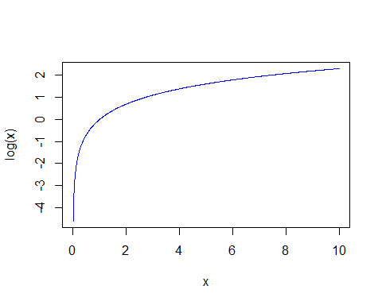

Note that the echo = FALSE parameter was added to the code chunk to prevent printing of the R code that generated the plot.

x <- c(1,2,3)  
x

## [1] 1 2 3

class(x)

## [1] "numeric"

y <- c(sqrt(2),sqrt(3),sqrt(5))  
y

## [1] 1.414214 1.732051 2.236068

class(y)

## [1] "numeric"

z <- c("pepito","juanito","jorgito")  
z

## [1] "pepito" "juanito" "jorgito"

class(z)

## [1] "character"

## Fonction rep()

x <- rep("pepito",10)  
x

## [1] "pepito" "pepito" "pepito" "pepito" "pepito" "pepito" "pepito"  
## [8] "pepito" "pepito" "pepito"

y <- rep(c(sqrt(2),sqrt(3)),5)  
y

## [1] 1.414214 1.732051 1.414214 1.732051 1.414214 1.732051 1.414214  
## [8] 1.732051 1.414214 1.732051

z <- c(rep("f",25),rep("h",75))  
z

## [1] "f" "f" "f" "f" "f" "f" "f" "f" "f" "f" "f" "f" "f" "f" "f" "f" "f"  
## [18] "f" "f" "f" "f" "f" "f" "f" "f" "h" "h" "h" "h" "h" "h" "h" "h" "h"  
## [35] "h" "h" "h" "h" "h" "h" "h" "h" "h" "h" "h" "h" "h" "h" "h" "h" "h"  
## [52] "h" "h" "h" "h" "h" "h" "h" "h" "h" "h" "h" "h" "h" "h" "h" "h" "h"  
## [69] "h" "h" "h" "h" "h" "h" "h" "h" "h" "h" "h" "h" "h" "h" "h" "h" "h"  
## [86] "h" "h" "h" "h" "h" "h" "h" "h" "h" "h" "h" "h" "h" "h" "h"

## Fonction seq()

x <- seq(from=-10,to=10,by=0.01)  
length(x)

## [1] 2001

## Valeurs manquantes

taille <- c(142,NA,189,156,NA,190)  
taille

## [1] 142 NA 189 156 NA 190

mean(taille,na="TRUE")

## [1] 169.25

sd(taille,na="TRUE")

## [1] 24.07454

is.na(taille)

## [1] FALSE TRUE FALSE FALSE TRUE FALSE

summary(taille)

## Min. 1st Qu. Median Mean 3rd Qu. Max. NA's   
## 142.0 152.5 172.5 169.2 189.2 190.0 2

## L’opèrateur :

x <- seq(from=100,100,by=2)  
x

## [1] 100

x[30]

## [1] NA

x[30:40]

## [1] NA NA NA NA NA NA NA NA NA NA NA

30:40

## [1] 30 31 32 33 34 35 36 37 38 39 40

1:100

## [1] 1 2 3 4 5 6 7 8 9 10 11 12 13 14 15 16 17  
## [18] 18 19 20 21 22 23 24 25 26 27 28 29 30 31 32 33 34  
## [35] 35 36 37 38 39 40 41 42 43 44 45 46 47 48 49 50 51  
## [52] 52 53 54 55 56 57 58 59 60 61 62 63 64 65 66 67 68  
## [69] 69 70 71 72 73 74 75 76 77 78 79 80 81 82 83 84 85  
## [86] 86 87 88 89 90 91 92 93 94 95 96 97 98 99 100

## Indexation par condition

sexe <- c(rep("f",25),rep("h",75))  
sexe

## [1] "f" "f" "f" "f" "f" "f" "f" "f" "f" "f" "f" "f" "f" "f" "f" "f" "f"  
## [18] "f" "f" "f" "f" "f" "f" "f" "f" "h" "h" "h" "h" "h" "h" "h" "h" "h"  
## [35] "h" "h" "h" "h" "h" "h" "h" "h" "h" "h" "h" "h" "h" "h" "h" "h" "h"  
## [52] "h" "h" "h" "h" "h" "h" "h" "h" "h" "h" "h" "h" "h" "h" "h" "h" "h"  
## [69] "h" "h" "h" "h" "h" "h" "h" "h" "h" "h" "h" "h" "h" "h" "h" "h" "h"  
## [86] "h" "h" "h" "h" "h" "h" "h" "h" "h" "h" "h" "h" "h" "h" "h"

taille <- rnorm(100,165,4)  
taille

## [1] 159.9751 169.1464 165.5398 157.9175 154.0340 164.6204 167.2038  
## [8] 159.4568 167.8977 167.5392 160.5758 158.9041 172.3509 161.8154  
## [15] 161.4450 164.6462 167.0821 157.6951 155.5816 159.1193 168.1887  
## [22] 160.7901 171.5375 166.7833 167.6531 170.7742 170.8102 169.4650  
## [29] 158.5879 169.8828 166.8361 167.6679 163.0026 167.5022 173.8626  
## [36] 167.3709 166.7671 163.4797 161.8110 160.3036 166.4316 164.1818  
## [43] 155.8641 168.8424 156.3991 168.4088 174.3854 168.1860 169.0953  
## [50] 163.0874 162.6075 166.0324 157.3853 162.2846 167.0648 169.9288  
## [57] 172.3289 166.4483 159.4261 154.9204 167.4575 167.0991 170.2198  
## [64] 171.1857 163.9443 169.8347 163.3010 159.9173 167.3512 165.6831  
## [71] 165.3065 163.7002 162.1115 174.7047 156.1865 157.8854 163.1889  
## [78] 162.8041 164.7376 164.6051 163.7004 162.8672 168.6234 165.4922  
## [85] 166.0146 162.9219 158.8783 165.8384 161.1935 165.3968 164.9948  
## [92] 154.3451 164.8690 172.6021 160.3084 164.3634 167.0228 169.1637  
## [99] 165.5908 167.4167

bd <- data.frame(sexe,taille)  
taille.h <- taille[sexe=="h"]  
taille.h

## [1] 170.7742 170.8102 169.4650 158.5879 169.8828 166.8361 167.6679  
## [8] 163.0026 167.5022 173.8626 167.3709 166.7671 163.4797 161.8110  
## [15] 160.3036 166.4316 164.1818 155.8641 168.8424 156.3991 168.4088  
## [22] 174.3854 168.1860 169.0953 163.0874 162.6075 166.0324 157.3853  
## [29] 162.2846 167.0648 169.9288 172.3289 166.4483 159.4261 154.9204  
## [36] 167.4575 167.0991 170.2198 171.1857 163.9443 169.8347 163.3010  
## [43] 159.9173 167.3512 165.6831 165.3065 163.7002 162.1115 174.7047  
## [50] 156.1865 157.8854 163.1889 162.8041 164.7376 164.6051 163.7004  
## [57] 162.8672 168.6234 165.4922 166.0146 162.9219 158.8783 165.8384  
## [64] 161.1935 165.3968 164.9948 154.3451 164.8690 172.6021 160.3084  
## [71] 164.3634 167.0228 169.1637 165.5908 167.4167

taille.f <- taille[sexe=="f"]  
taille.f

## [1] 159.9751 169.1464 165.5398 157.9175 154.0340 164.6204 167.2038  
## [8] 159.4568 167.8977 167.5392 160.5758 158.9041 172.3509 161.8154  
## [15] 161.4450 164.6462 167.0821 157.6951 155.5816 159.1193 168.1887  
## [22] 160.7901 171.5375 166.7833 167.6531

boxplot(taille.h,taille,taille.f)

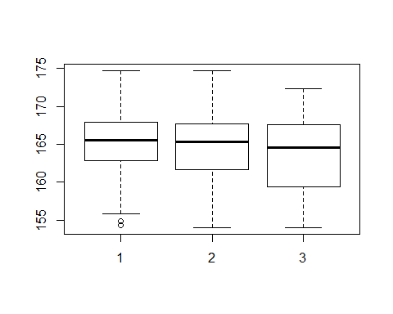

mean(taille)

## [1] 164.7176

mean(taille.f)

## [1] 163.4999

mean(taille.h)

## [1] 165.1235

sexe.n <- sexe[taille < 164]  
sexe.n

## [1] "f" "f" "f" "f" "f" "f" "f" "f" "f" "f" "f" "f" "h" "h" "h" "h" "h"  
## [18] "h" "h" "h" "h" "h" "h" "h" "h" "h" "h" "h" "h" "h" "h" "h" "h" "h"  
## [35] "h" "h" "h" "h" "h" "h" "h"

(table(sexe.n)/length(taille))*100

## sexe.n  
## f h   
## 12 29

```